1. Login to the AWS root user account.

2. Create a new IAM user and configure it with both programmatic and console access.

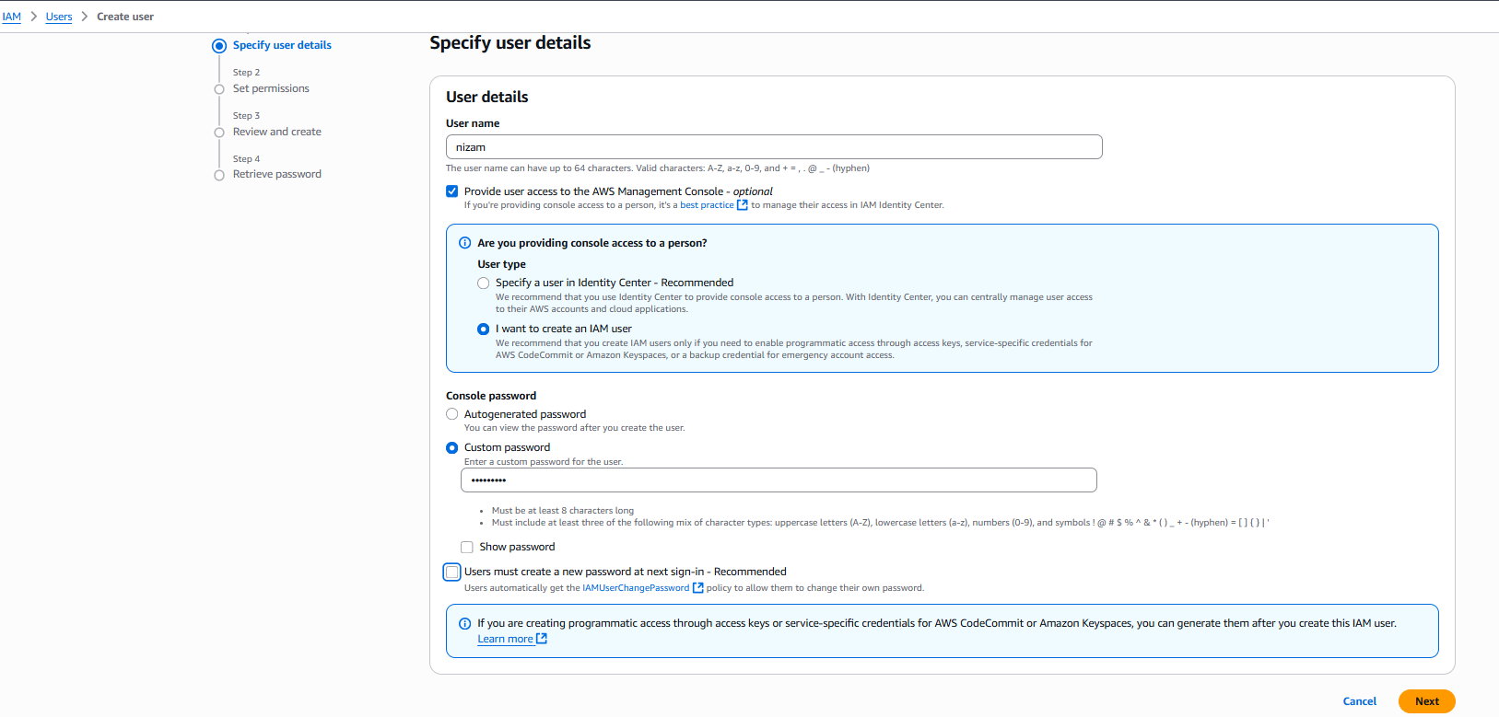

Attach the AmazonEC2FullAccess policy to this user.

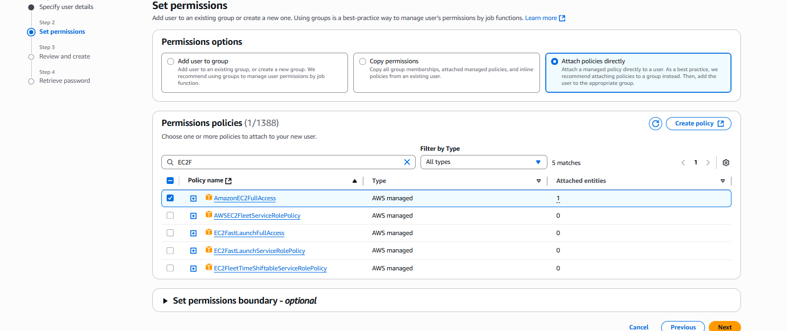

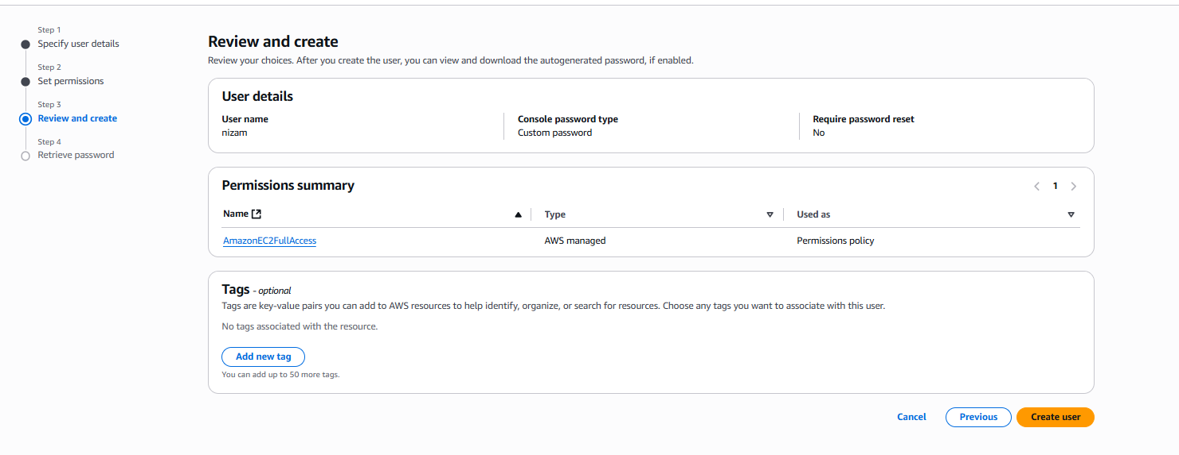

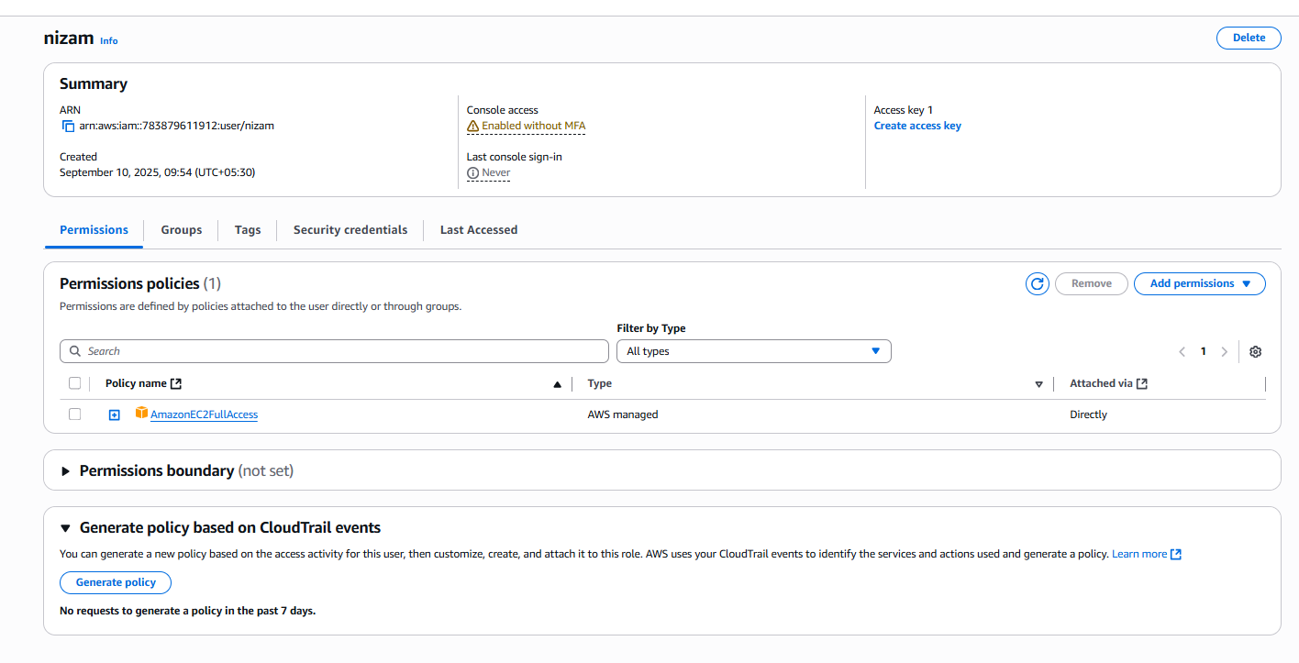

Login with the newly created IAM user.

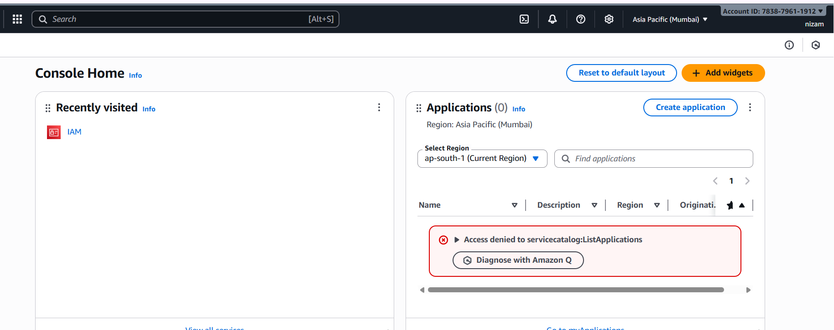

3. Launch an EC2 instance with the following configuration:

Region: Mumbai (ap-south-1) OS: Ubuntu

Instance type: t2.micro (Free Tier eligible) Storage: Root EBS volume of 8 GB

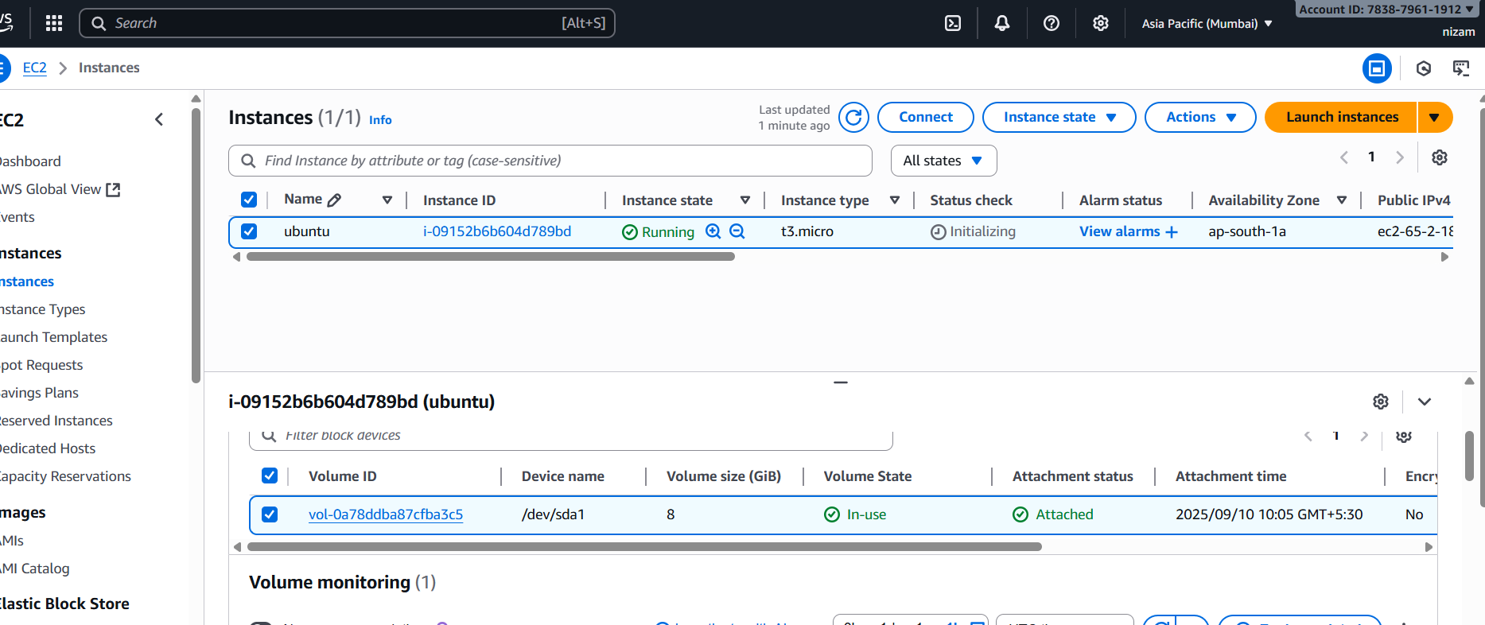

4. Once the EC2 instance is launched:

Access the instance and verify the attached root volume.

Do NOT attach any new EBS volume.

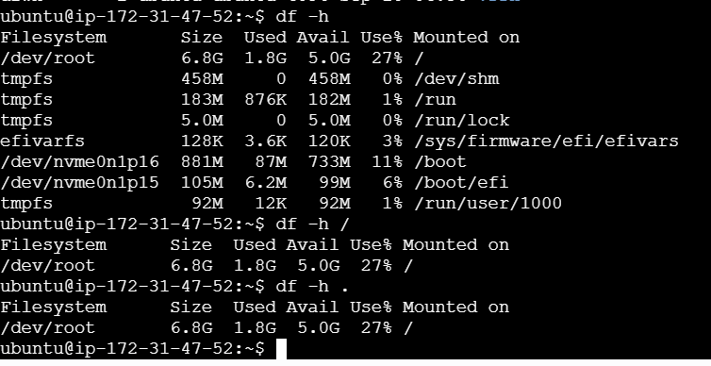

5. Modify the Root EBS Volume (8 GB → 12 GB):

First, go to the AWS Management Console and modify the volume size to 12 GB.

Restart the EC2 instance and check if the change is reflected.

Verify whether the file system shows updated storage or not.

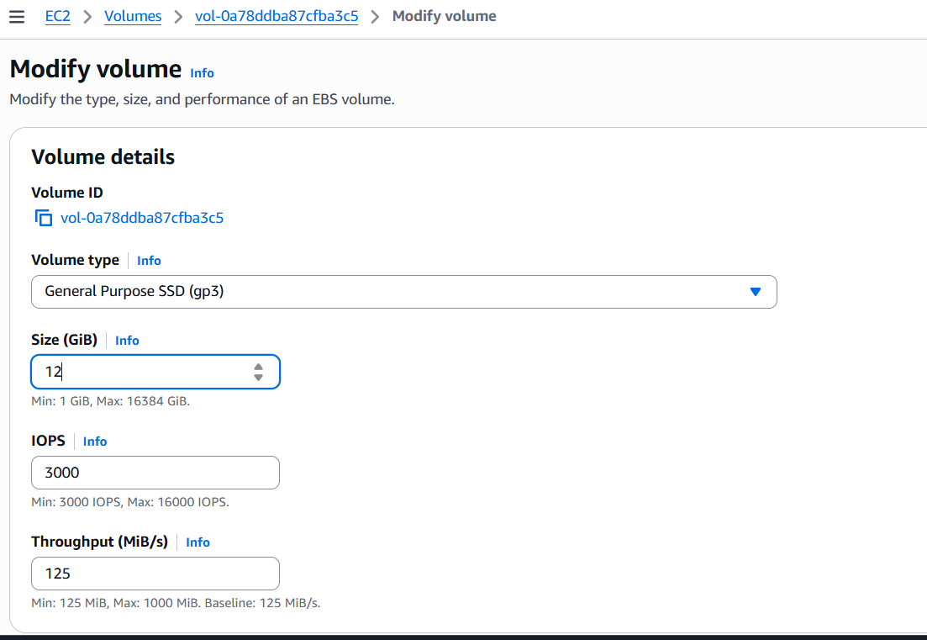

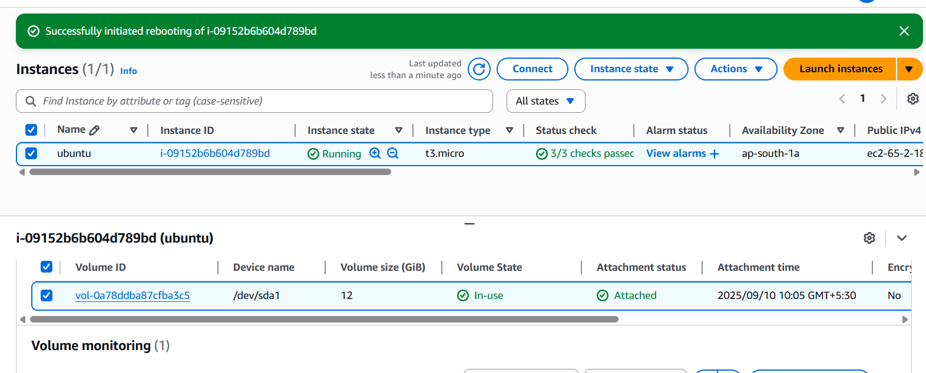

6. Resize from Terminal (CLI Method):

If the updated size is not reflected, log in to the EC2 instance.

Use commands to extend the file system manually.

Confirm that the storage now shows 12 GB usable.

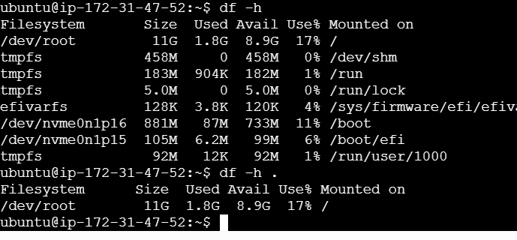

7. Update system packages inside the EC2 instance using:

Ubuntu → sudo apt update && sudo apt upgrade -y

Amazon Linux → sudo yum update -y

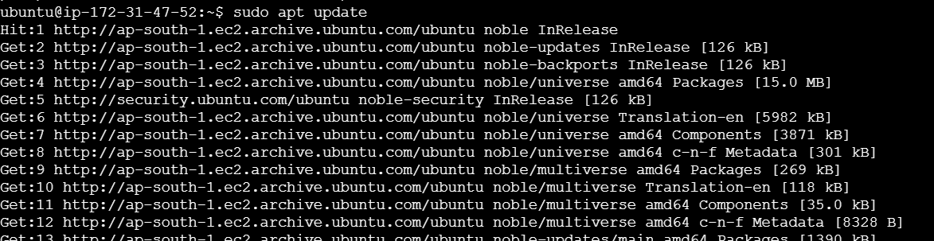

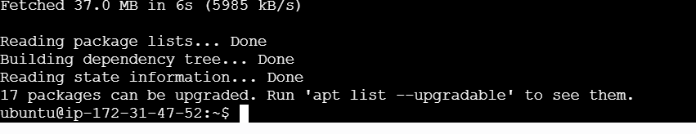

8. Disable internet access for EC2, then try to update any package (should fail).

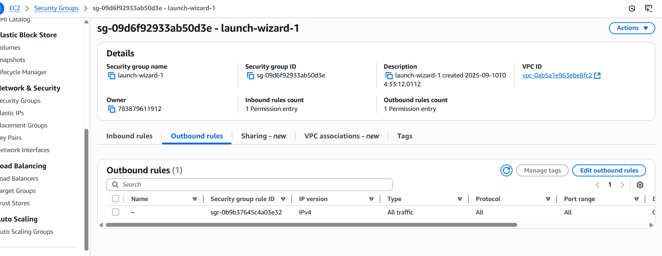

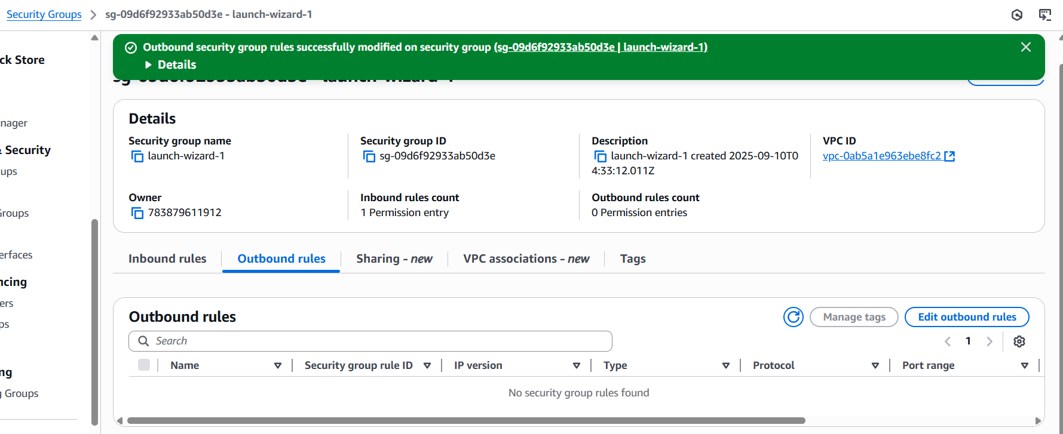

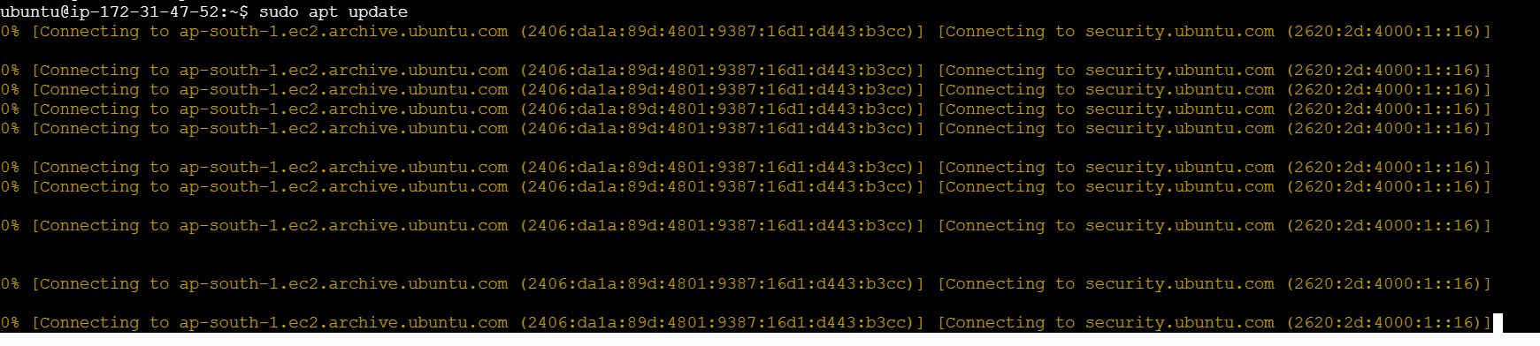

9. Enable the internet again and retry package update (should work).

